Ingestion Fabric

From Azure SQL to Frabric Lakehouse
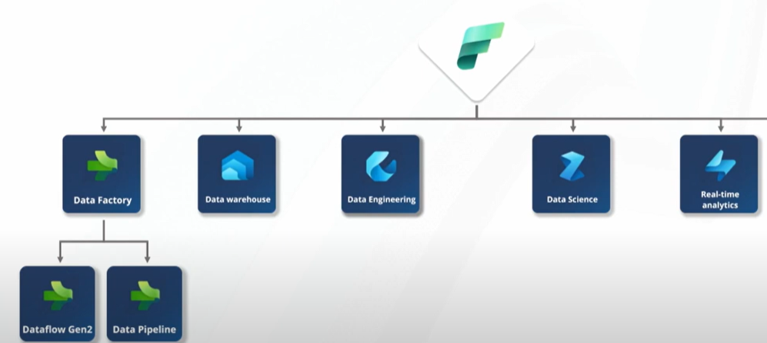

Usining Data Flow
https://www.youtube.com/watch?v=RA9dFH94cuU

Using Data pipeleine

